Joomla Additional filetypes

System Menu
- Login to Joomla Administration
- Click on System
- Click on Global Configuration
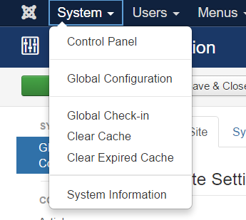
- Click on System
- Then from the side choose Media

Media Menu

Legal Extensions (File Types)
- Default Options
  - bmp,csv,doc,gif,ico,jpg,jpeg,odg,odp,ods,odt,pdf,png,ppt,txt,xcf,xls,BMP,CSV,DOC,GIF,ICO,JPG,JPEG,ODG,ODP,ODS,ODT,PDF,PNG,PPT,TXT,XCF,XLS
- Our Proposed Options
  - svgz,svg,bmp,csv,doc,gif,ico,jpg,jpeg,odg,odp,ods,odt,pdf,png,ppt,txt,xcf,xls,BMP,CSV,DOC,GIF,ICO,JPG,JPEG,ODG,ODP,ODS,ODT,PDF,PNG,PPT,TXT,XCF,XLS

Legal MIME Types
- Default Options
  - image/jpeg,image/gif,image/png,image/bmp,application/msword,application/excel,application/pdf,application/powerpoint,text/plain,application/x-zip
- Our Proposed Options
  - image/jpeg,image/gif,image/png,image/bmp,application/msword,application/excel,application/pdf,application/powerpoint,text/plain,application/x-zip,image/svg+xml

