Joomla Caching

System Menu
- Login to Joomla Administration
- Click on System
- Click on Global Configuration
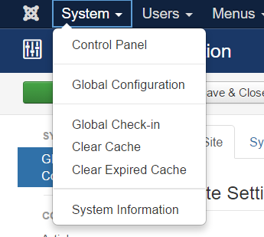
- Click on System
- Then copy the settings that follow for Cache and Session Settings depending on the Engine you want to use.

Cache

memcached
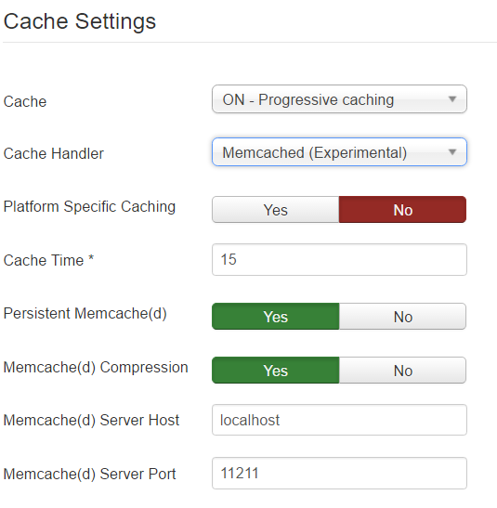

redis
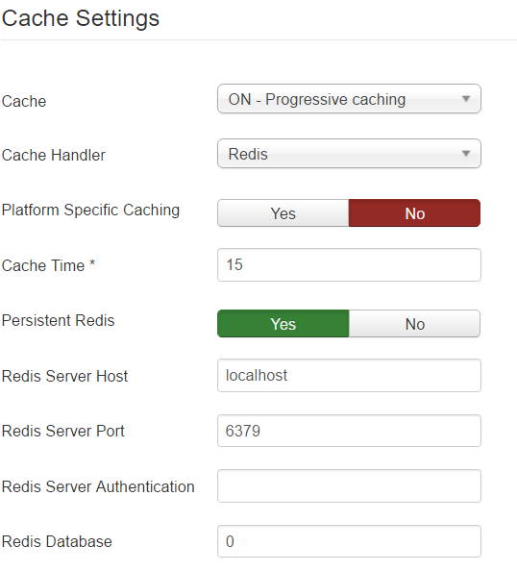
Important: Set the database allocated to you in your account, otherwise redis will not work.

memcache
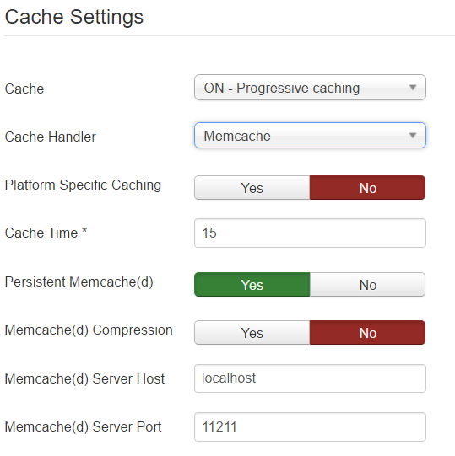

Session

memcached
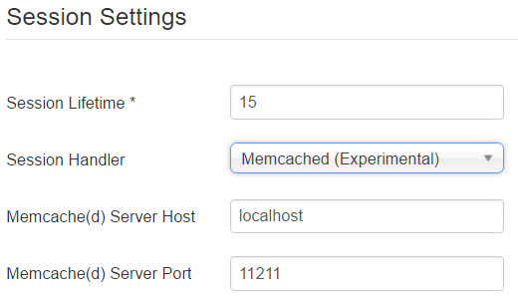

redis
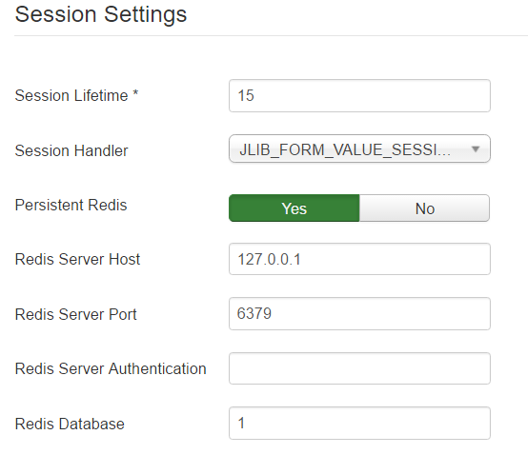
Important: Set the database allocated to you in your account, otherwise redis will not work.

memcache
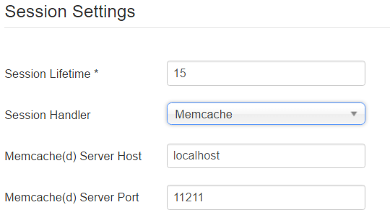

Notes
The moment you set a new session handler you will be logged out of administration, just log back in.

